Basics Knowledge of “Operator Training Record” Program

1. How to Login

2. How to use main welcome page
How to see the skill record of each operator
How to download by Current Skill

How to download skill
How to Download skill for all employee
How to download skill by Section
How to download skill by Expiry date
How to download skill by Disqualification
How to download skill by Resignation
How to download skill by Obsoleted
How to download by Operator No Skill

How to use OTR for Trainer
How to add employee
How to add skill
How to update skill
How to Disqualified skill

1. How to Login
1.1 Please Double Click icon “Operator Training Record”
1.2 Login to “Operator Training Record”
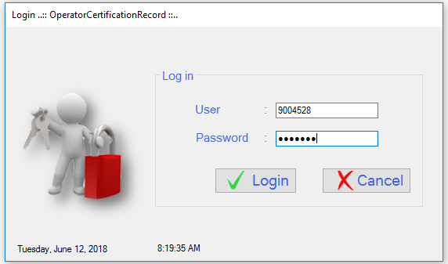
1. Input “Employee number & Password “

2. Click Login
Login by enter the Employee number Ex : User: 9004528 Password: xxxxxxx

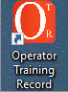

1.3 Show main welcome page
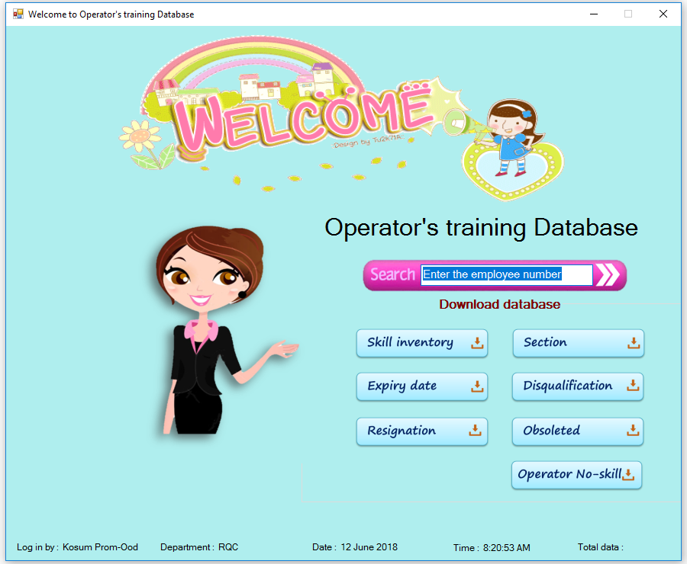

2. How to use main welcome page
2.1) How to see the skill record of each operator.
2.1.1 Enter the employee no. to see training result.
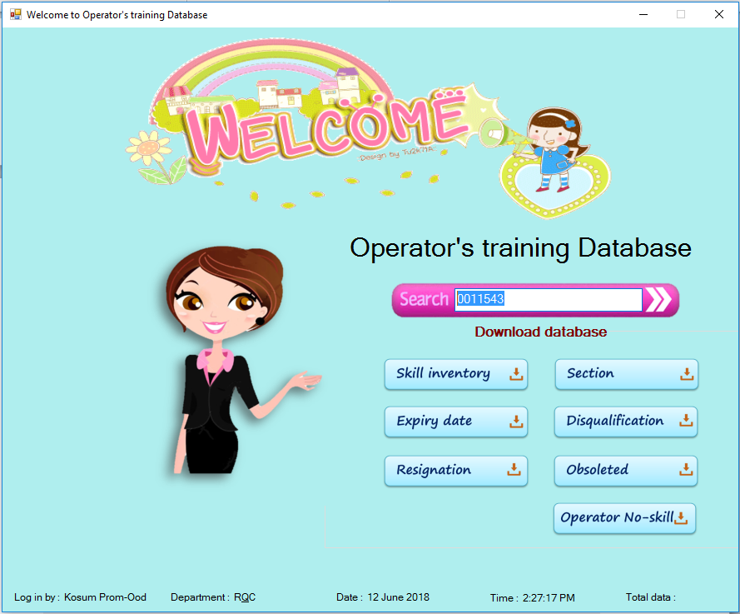
1. Input Employee id
2.1.1.2 Show Current Skill Page
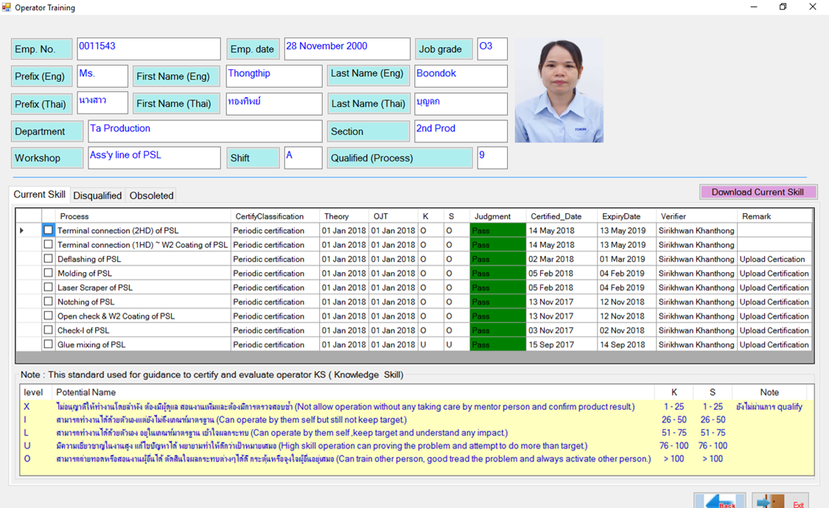
2.2) How to download by Current Skill
1. Click “Download Current Skill” button

3. Total 9 Skill Click “OK”
2. Click “Yes” to download
Click “No” to cancel download

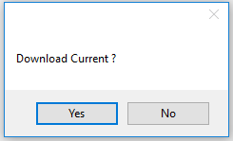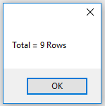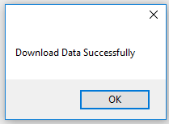
4. Click “OK” Download Complete.

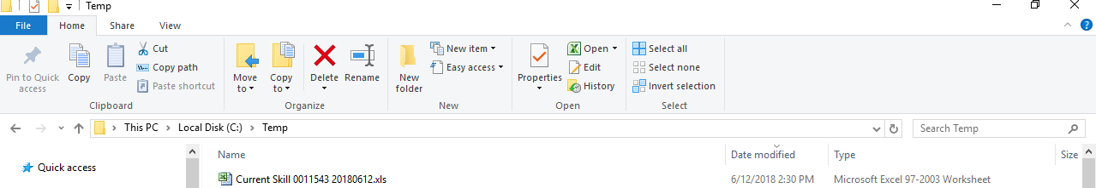
5. File save to C:\Temp\ Current skill (Employee no.)

2.1.2 show Disqualified Page
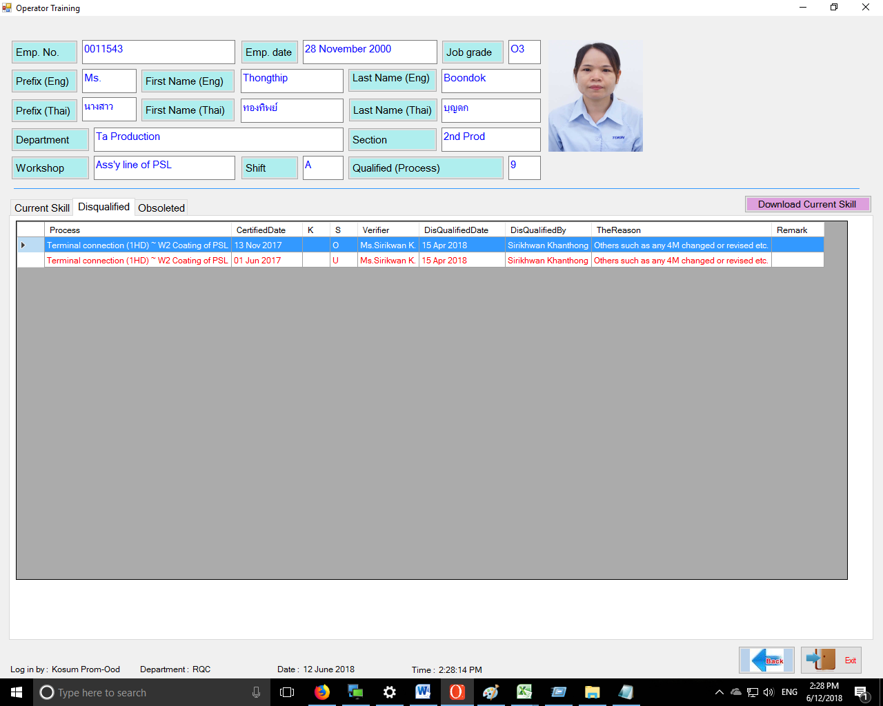

2.1.3 Show Obsoleted Page (Expired skills)
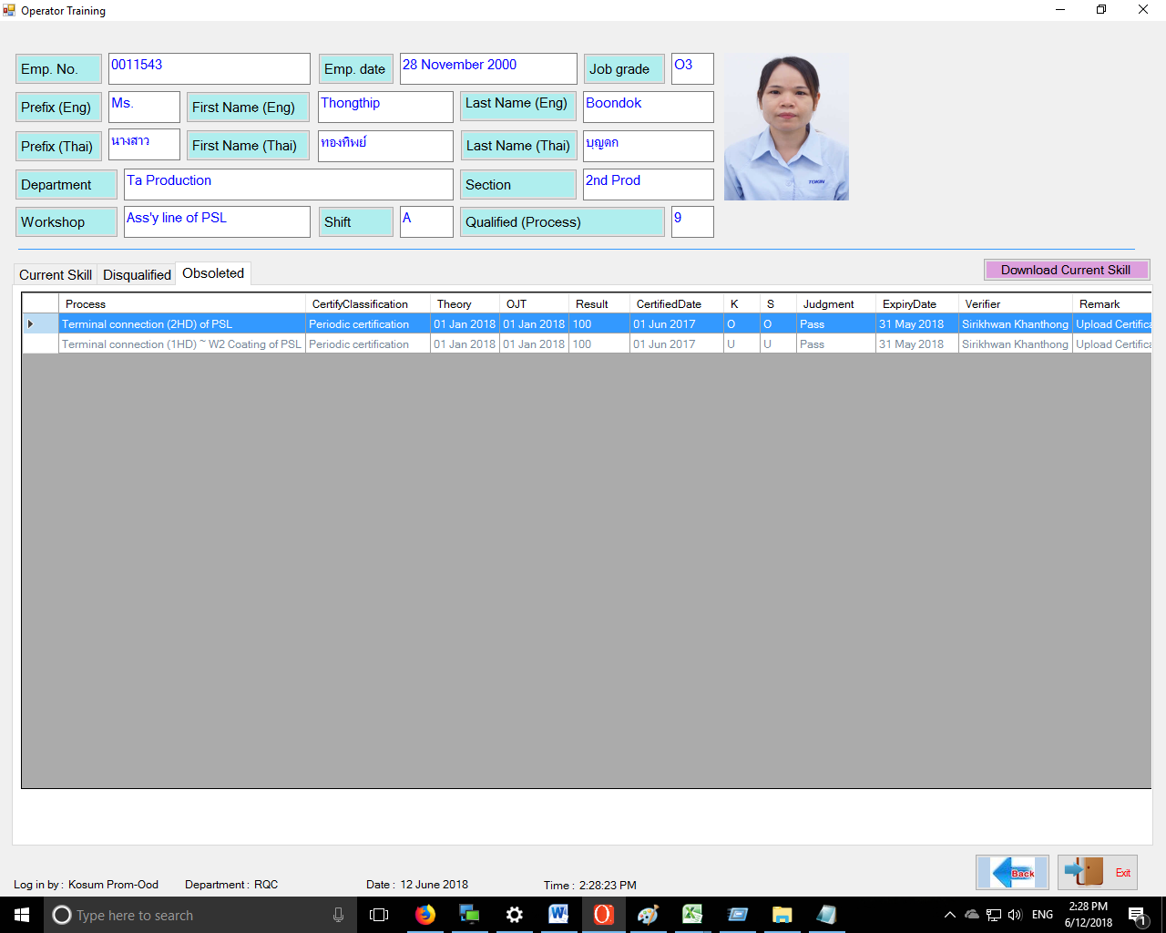

How to Download skill
1. How to Download skill for all employee
2. Click “Yes”

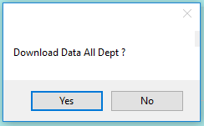
1. Click “Skill inventory”
7

6

4

2

5

3

1

แ
แ
แ
แแ
แ
แ
แแ
3. Total 3154 Skill Click “OK”

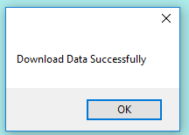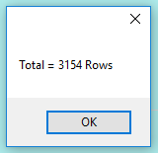

4. Click Download Complete.
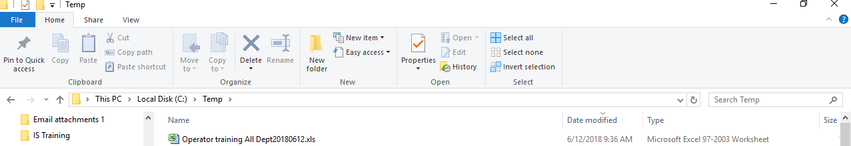

5. File save to C:\Temp

2. How to download skill by Section
1. Click “Section” button

2. Select Department Click “Download “

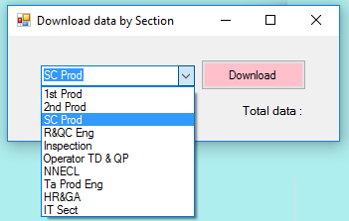
3. Click “Yes”
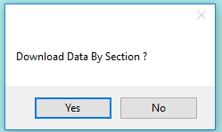
4. Total 481 Skill Click “OK”
5. Click “OK” Download Complete.
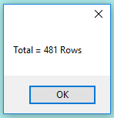

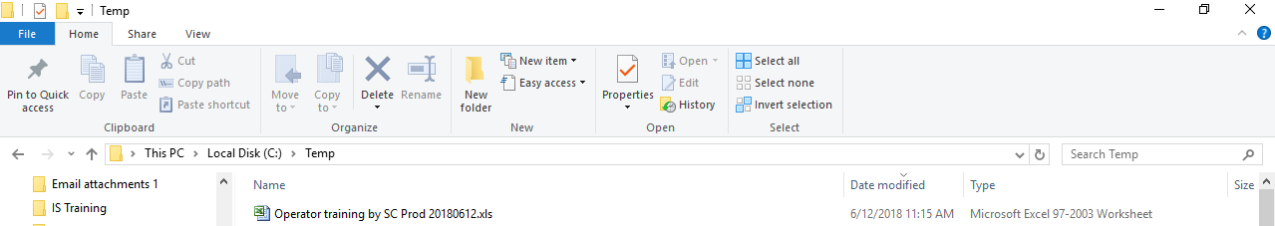
6. File save to C:\Temp

3.How to download skill by Expiry date
1. Click “Section” button


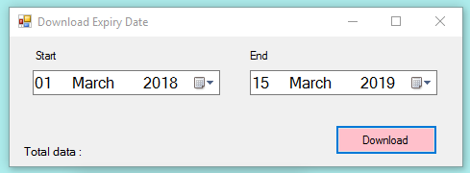
2. Select Date Click “Download “

3. Click “Yes”
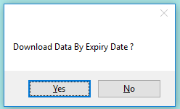
4. Total 481 Skill Click “OK”

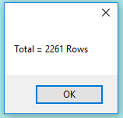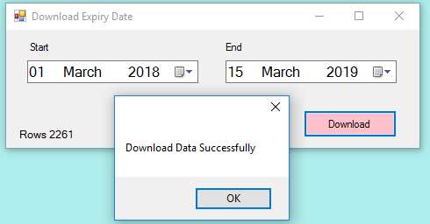
5. Click “OK” Download Complete.

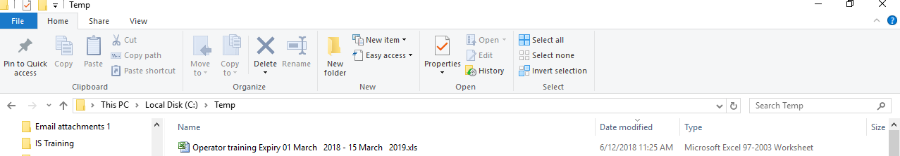
6. File save to C:\Temp

4. How to download skill by Disqualification

1. Click “Section” button

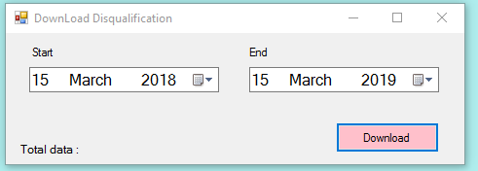
2. Select Date Click “Download “

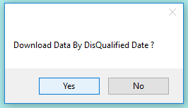
5. Click “OK” Download Complete.
3. Click “Yes”

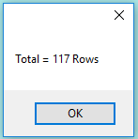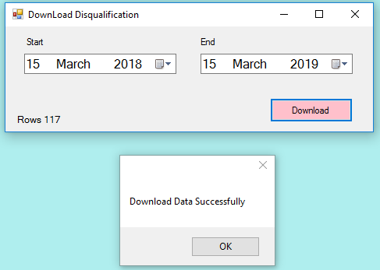
4. Total 117 Skill Click “OK”

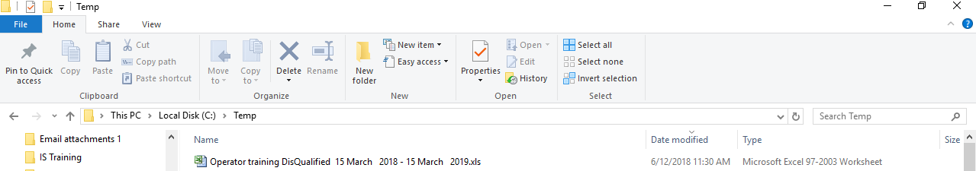
6. File save to C:\Temp
5. How to download skill by Resignation
1. Click “Resignation” button


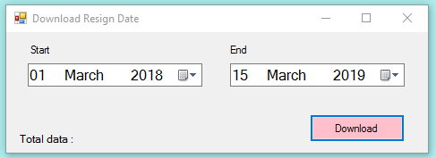
2. Select Date Click “Download “

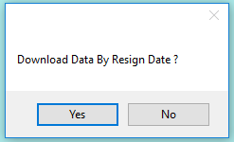
5. Click “OK” Download Complete.
3. Click “Yes”
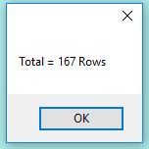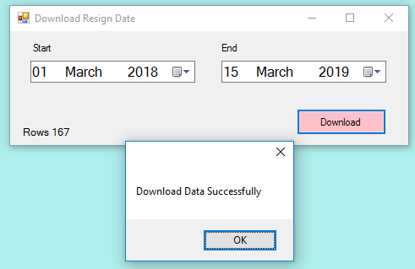
4. Total 117 Skill Click “OK”

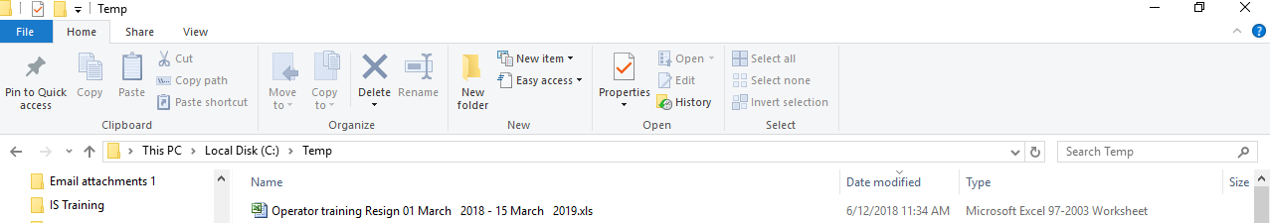
6. File save to C:\Temp

6. How to download skill by Obsoleted
1. Click “Obsoleted” button

2. Click “Yes”
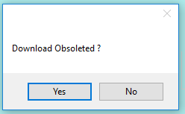

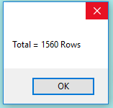
3. Total 1560 Skill Click “OK”

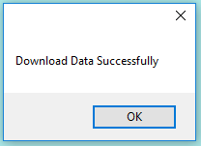
4. Click “OK” Download Complete.

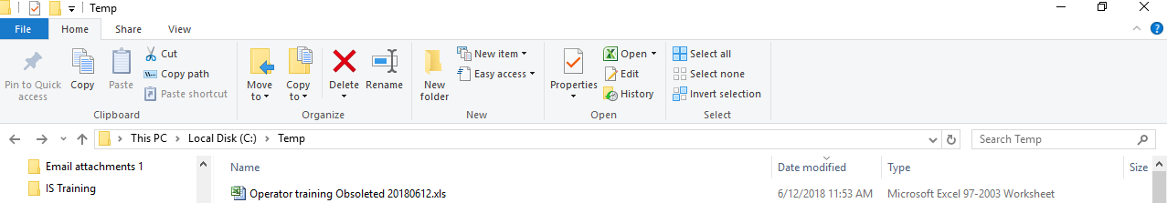
5. File save to C:\Temp

7. How to download by Operator No Skill
1. Click “Obsoleted” button

4. Click “OK” Download Complete.
3. Total 49 Skill Click “OK”
2. Click “Yes”
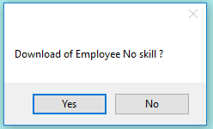

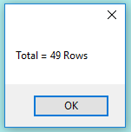



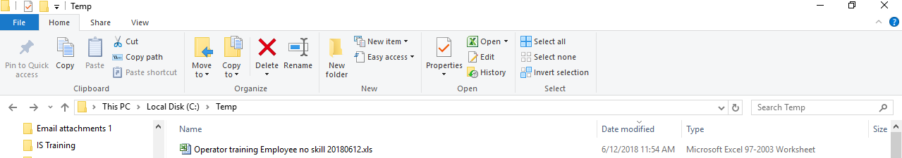

5. File save to C:\Temp

How to use OTR for Trainer
1. How to add employee
1.1 Login by Trainer id.
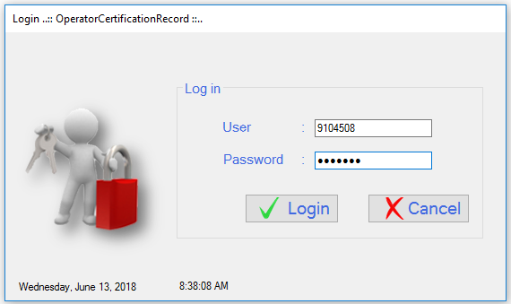

1.2 Click “Add employee”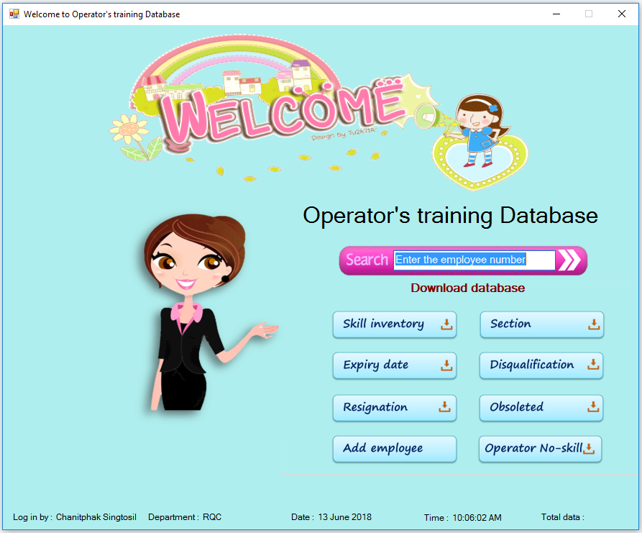
1. Click “Add employee” button
1.3 Detail add user
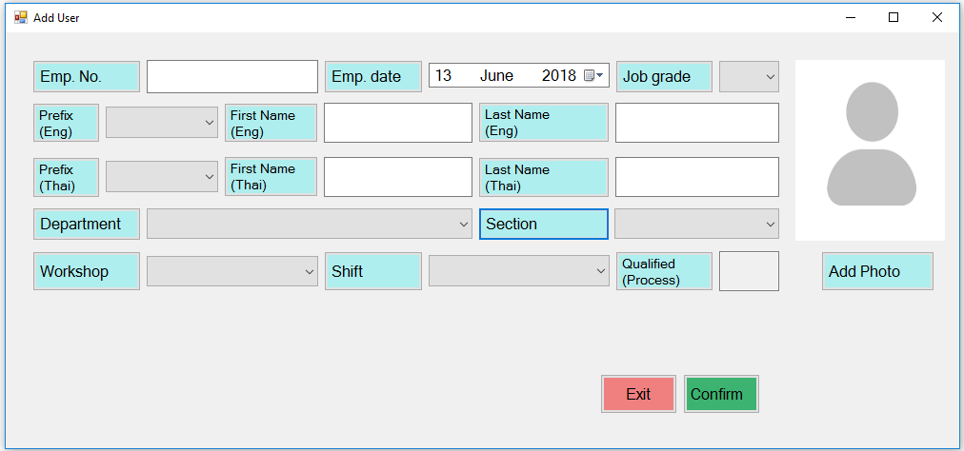
1.4 Input employee
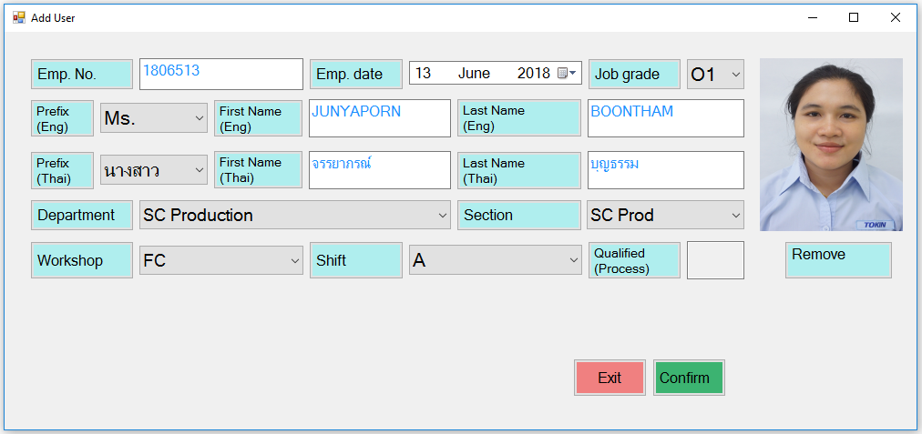
1. Click “Confirm”
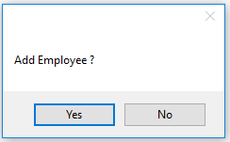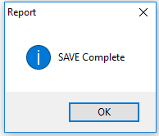
3. Click “OK” SAVE Complete.
2. Click “Yes”
1.5 Check status
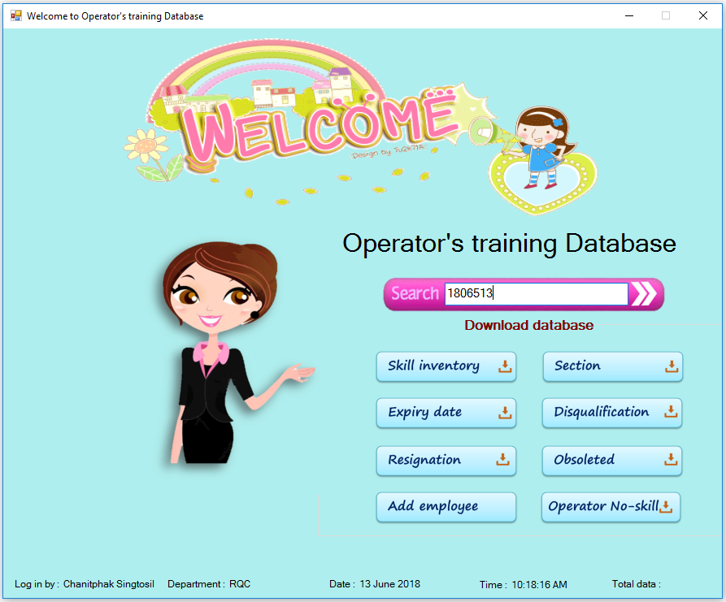

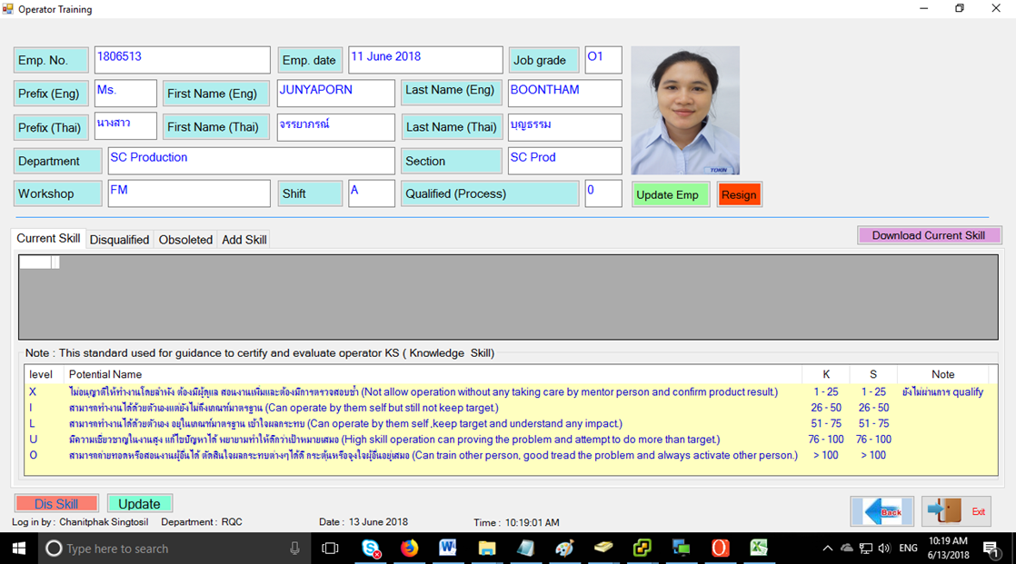
2. How to add skill
2.1 Input data and upload certification record by PDF.
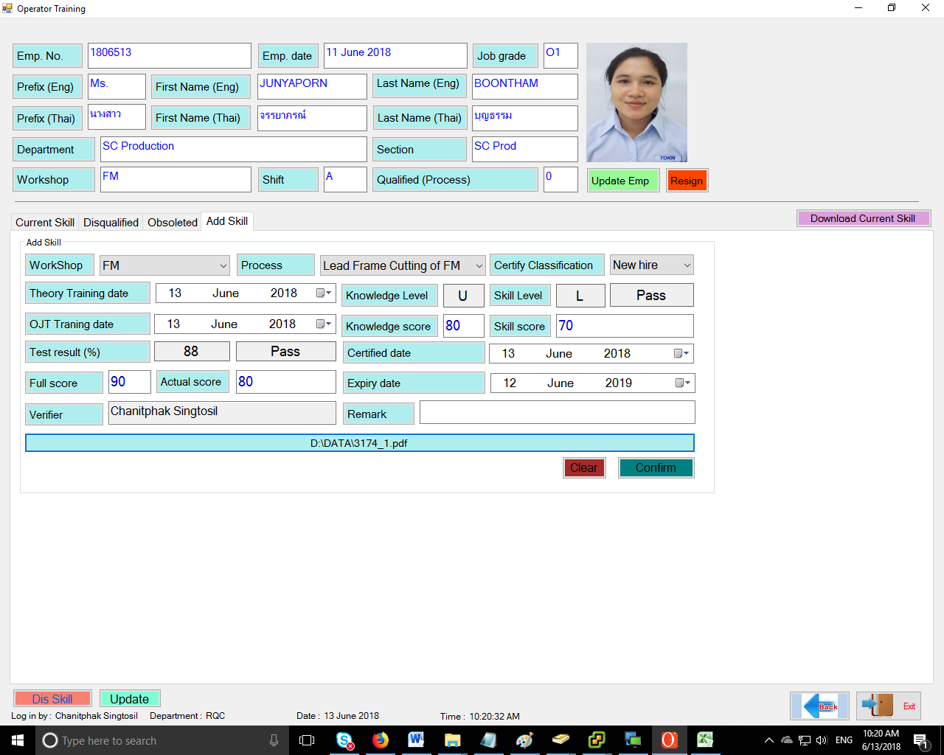
1. Click “Confirm”

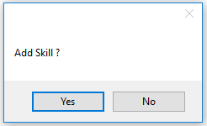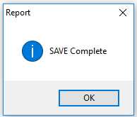
3. Click “OK” SAVE Complete.
2. Click “Yes”

2.2 Current skill
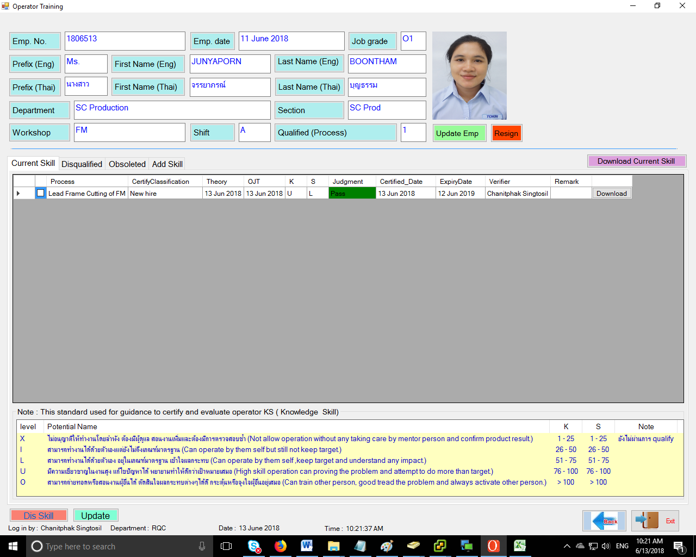

3. How to update skill
3.1 Select process click “update”
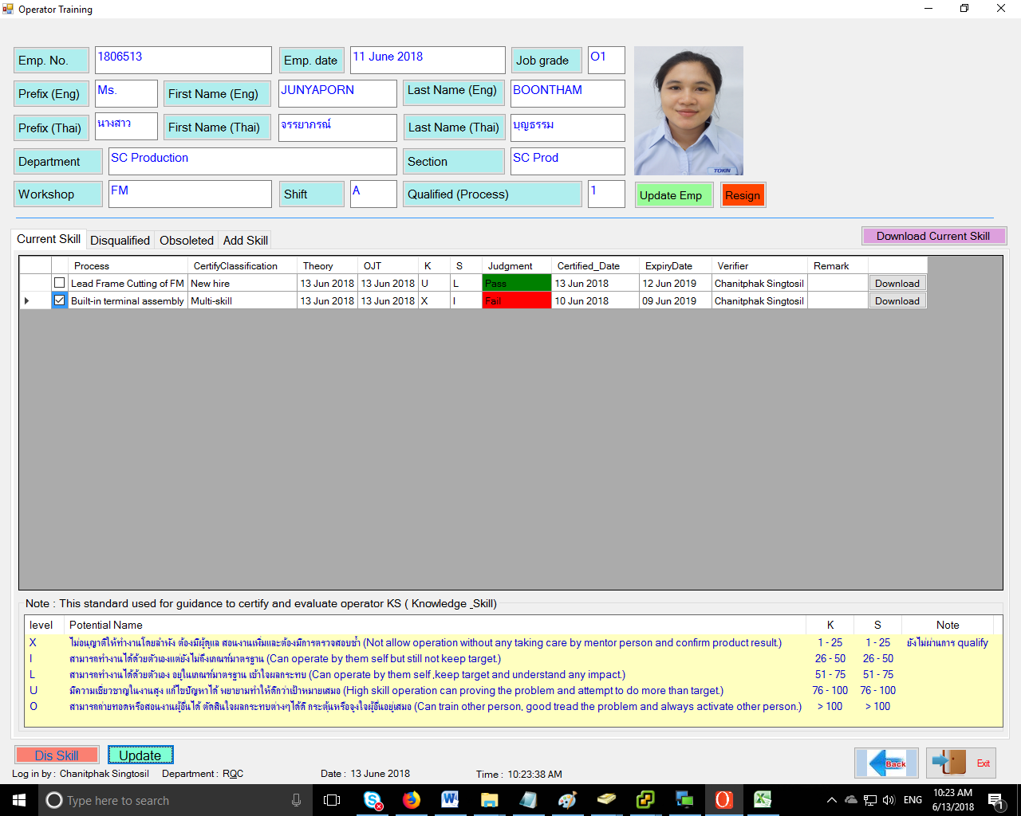
1. select “Process”
2. Click “Update”

3.2 Update data and upload certification record by PDF.
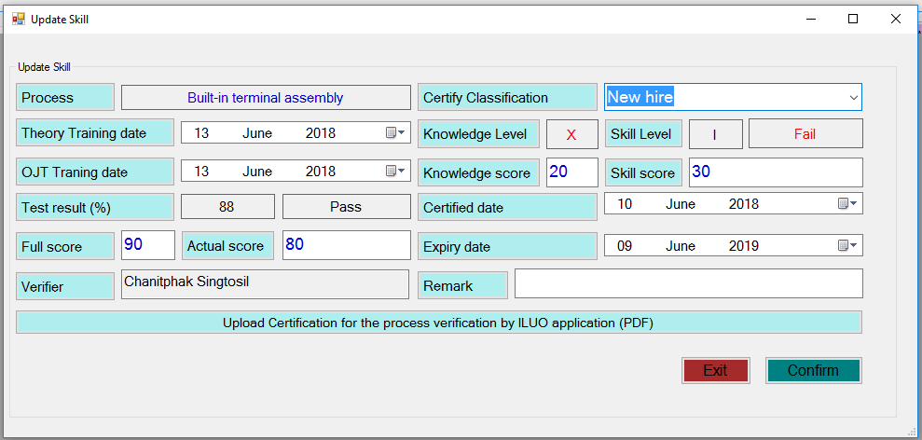
3.3 Input update skill click “Confirm”
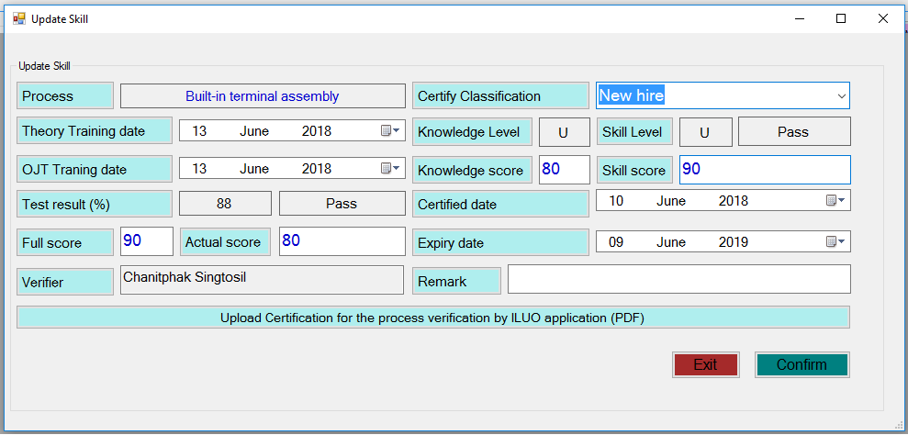
1. Click “Confirm”
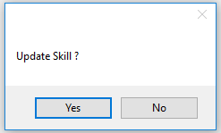
3. Click “OK” SAVE Complete.
2. Click “Yes”
3.4 Check data updated at Current skill tab.
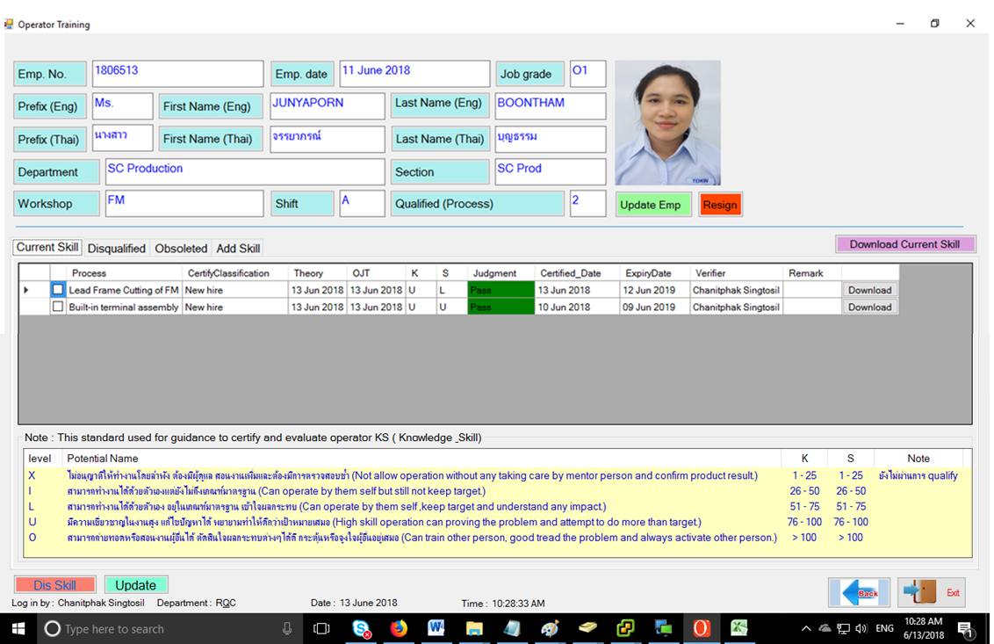
3.5 Old skill moved to Obsoleted tab.
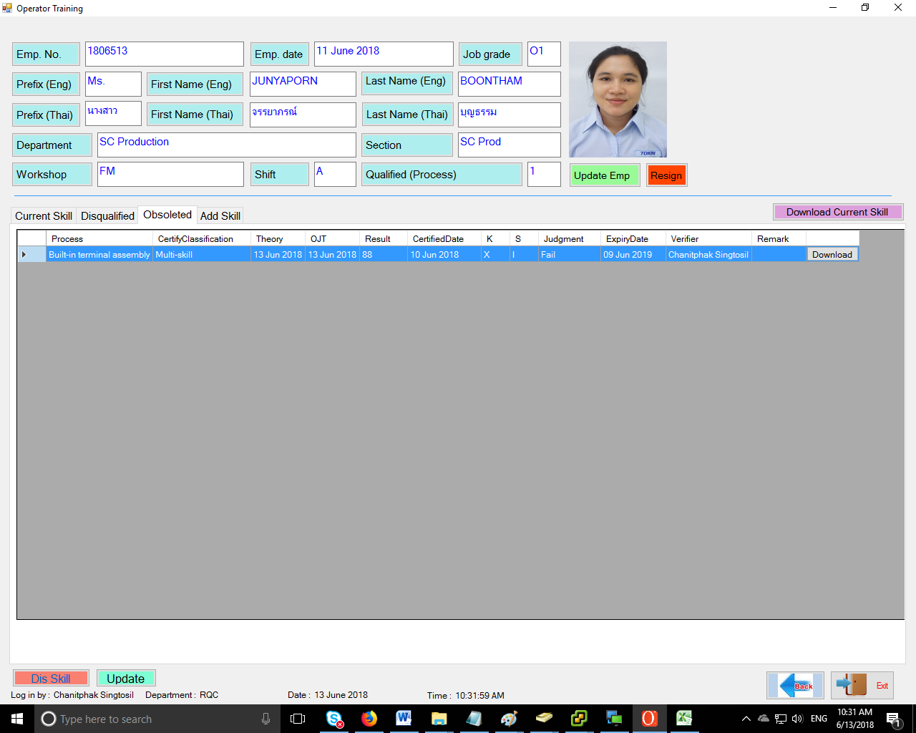
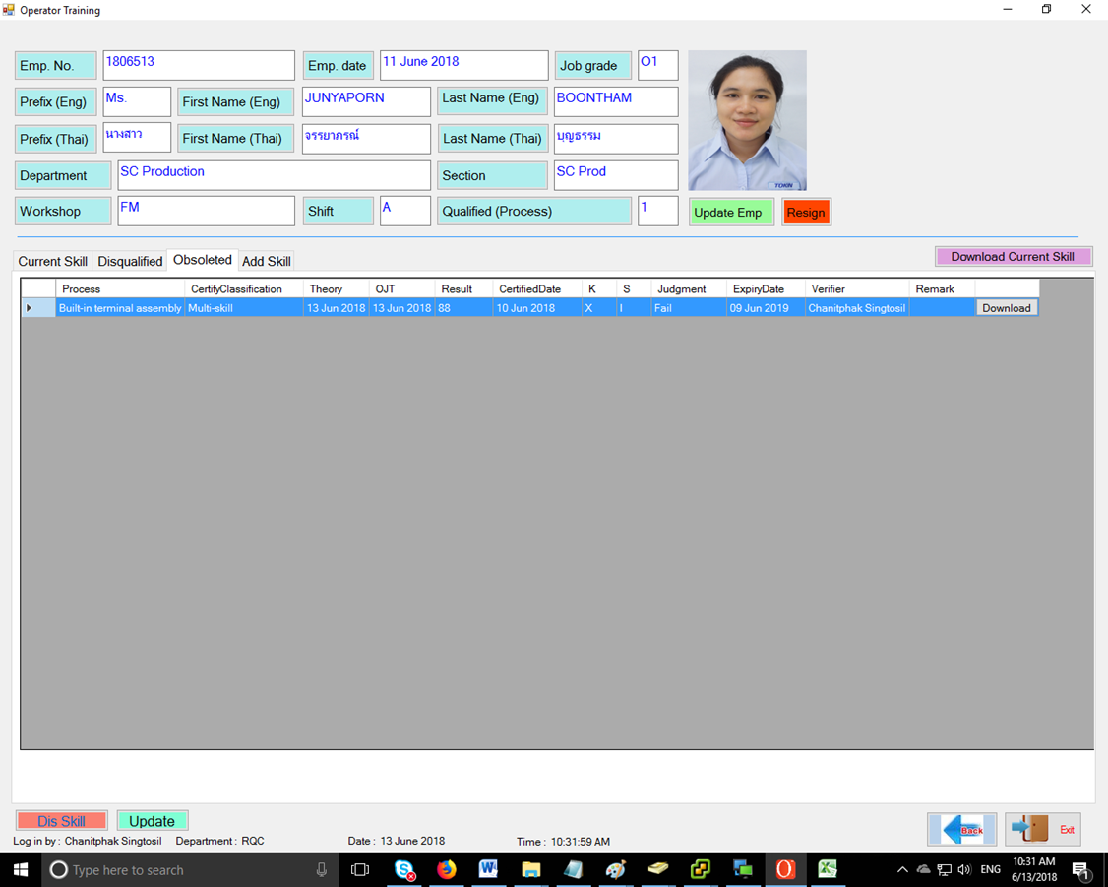

4. How to Disqualified skill
4.1 Select process click “Dis Skill”
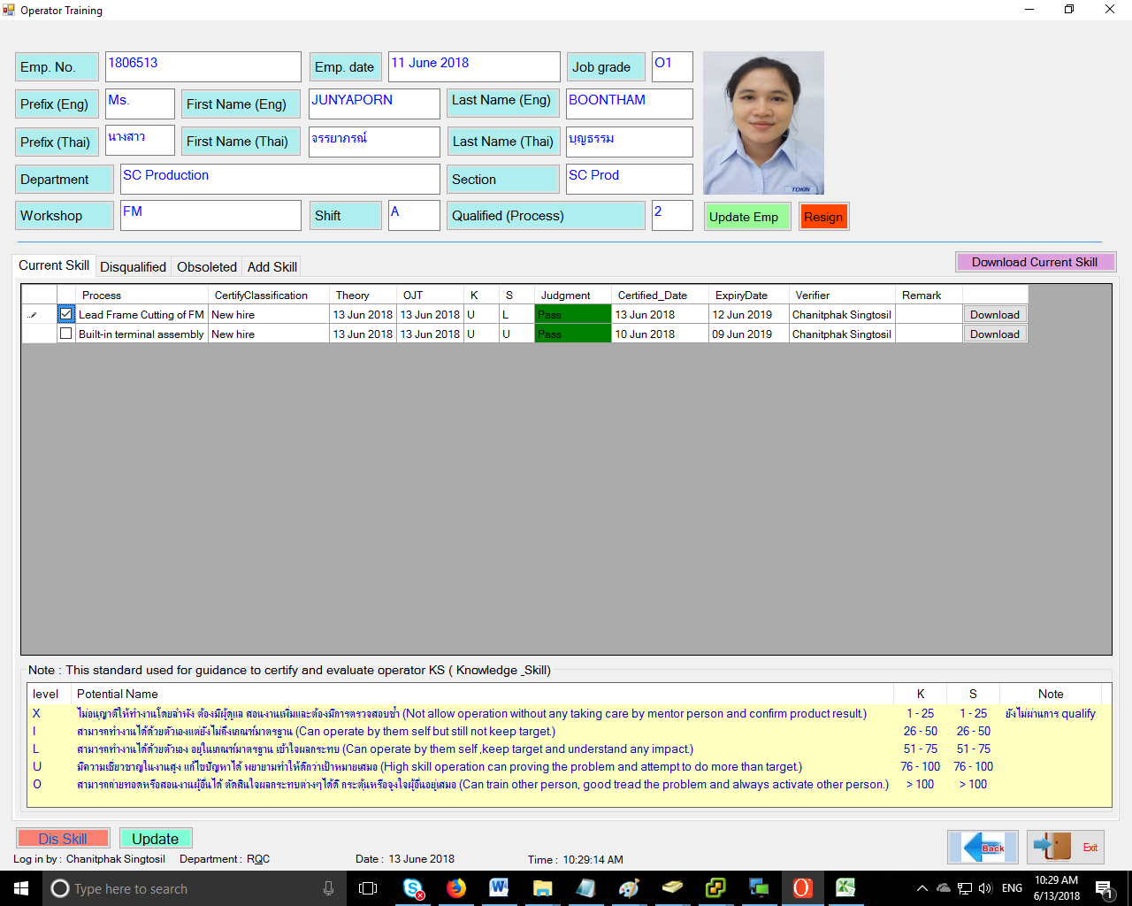
2. Click “Dis Skill”
1. select “Process”

4.2 Show popup “Disqualification”
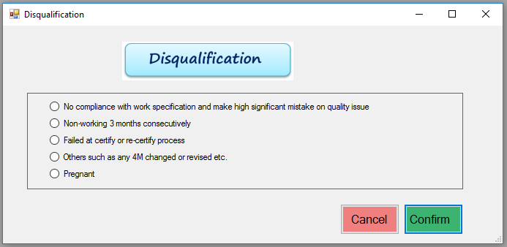
4.3 Select “Disqualification” Click “Confirm”

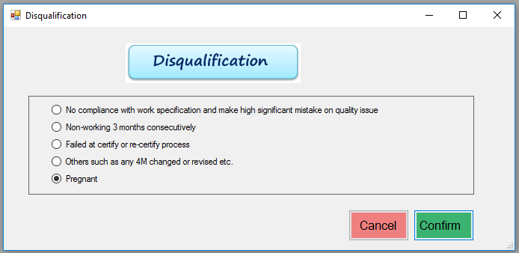

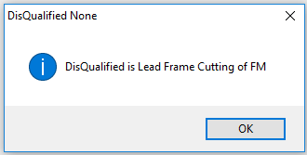

4.4 Show Current page
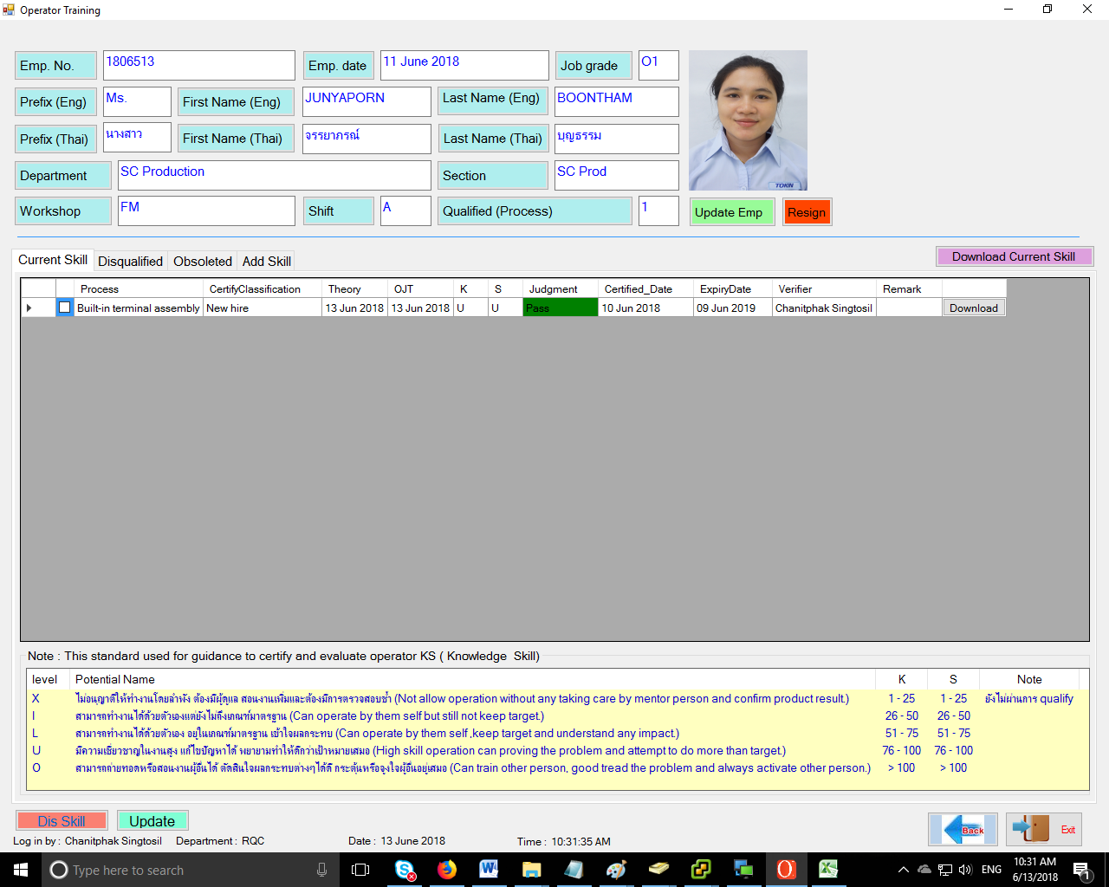

4.5 Old skill moved to “Disqualified” tab.
